**LIT TRAINING**

Name: Pataparla Thanusha

Employee ID: 46255251

Q1. **CDS-Assignment 1 – Create a Simple CDS view with Date Functions in ABAP CDS Views**

Code:

@AbapCatalog.sqlViewName: 'Z5251_SIMPLE_SQL'

@AbapCatalog.compiler.compareFilter: true

@AbapCatalog.preserveKey: true

@AccessControl.authorizationCheck: #NOT_REQUIRED

@EndUserText.label: 'SIMPLE CDS WITH SELECT'

**define** **view** Z5251_SIMPLE_CDS **as** **select** **from** vbak **{**

vbeln **as** Sales_Document**,**

auart **as** Sales_Document_Type**,**

audat **as** Document_Date**,**

vdatu **as** Requested_delivery_date**,**

DATS_DAYS_BETWEEN**(**audat**,** vdatu**)** **as** no_of_days**,**

DATS_ADD_DAYS**(**vdatu**,** 10**,** 'NULL'**)** **as** shipping_date**,**

DATS_ADD_MONTHS**(**vdatu**,** 2**,** 'NULL'**)** **as** billing_date

**}**

OUTPUT:

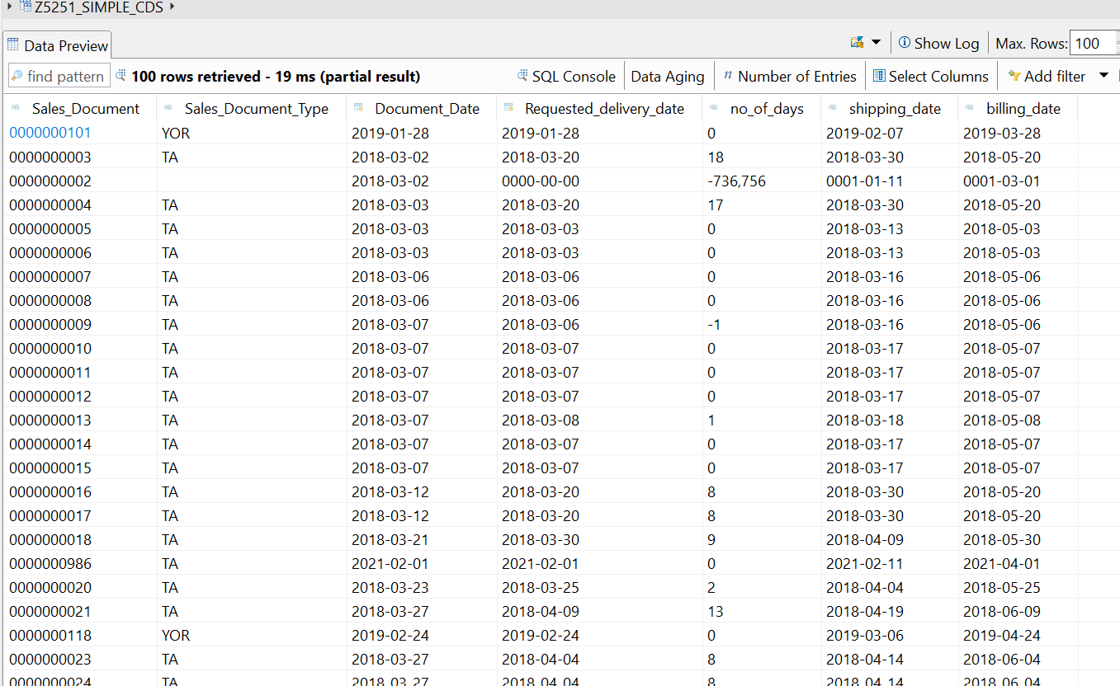

CDS-Assignment 2 – Create a Simple CDS view with String Functions in ABAP CDS Views

Code:

@AbapCatalog.sqlViewName: 'Z5251_STR_CDS'

@AbapCatalog.compiler.compareFilter: true

@AbapCatalog.preserveKey: true

@AccessControl.authorizationCheck: #NOT_REQUIRED

@EndUserText.label: 'Simple cds with string fns'

**define** **view** Z5251_STRING_CDS **as** **select** **from** kna1 **{**

kunnr **as** Customer_Number**,**

land1 **as** Country_Key**,**

CONCAT**(**name1**,** name2**)** **as** Full_Name**,**

CONCAT_WITH_SPACE**(**stras**,** ort01**,** 4 **)** **as** COMBO**,**

left**(**name1**,** 2**)** **as** F2C_NAME1**,**

RIGHT**(**name1**,** 3**)** **as** L3C_NAME2**,**

LENGTH**(**telf1**)** **as** NAME_LENGTH**,**

SUBSTRING**(**name1**,** 2**,** 4**)** **as** SUB**,**

LTRIM**(**kunnr**,** '0'**)** **as** l_TRIM**,**

RTRIM**(**telf1**,** '4'**)** **as** R_TRIM

**}**

OUTPUT:

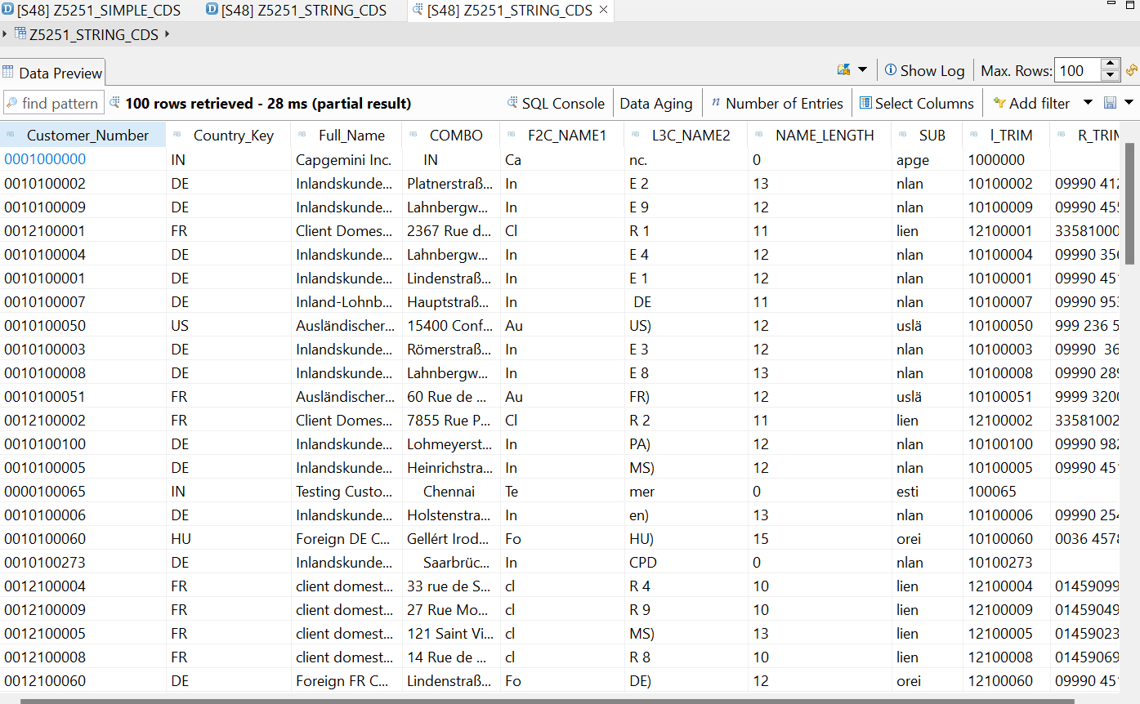

CDS-Assignment 3 – Create a Simple CDS view with Parameters

Code:

@AbapCatalog.sqlViewName: 'Z5251_PAR_SQL'

@AbapCatalog.compiler.compareFilter: true

@AbapCatalog.preserveKey: true

@AccessControl.authorizationCheck: #NOT_REQUIRED

@EndUserText.label: 'VIEW WITH PAR'

**define** **view** Z5251_PAR

**with** **parameters** S_PSWSL **:** *abap***.***cuky***(**5**)**

**as** **select** **from** bseg **{**

**\***

**}where** pswsl **=** **$parameters.**S_PSWSL**;**

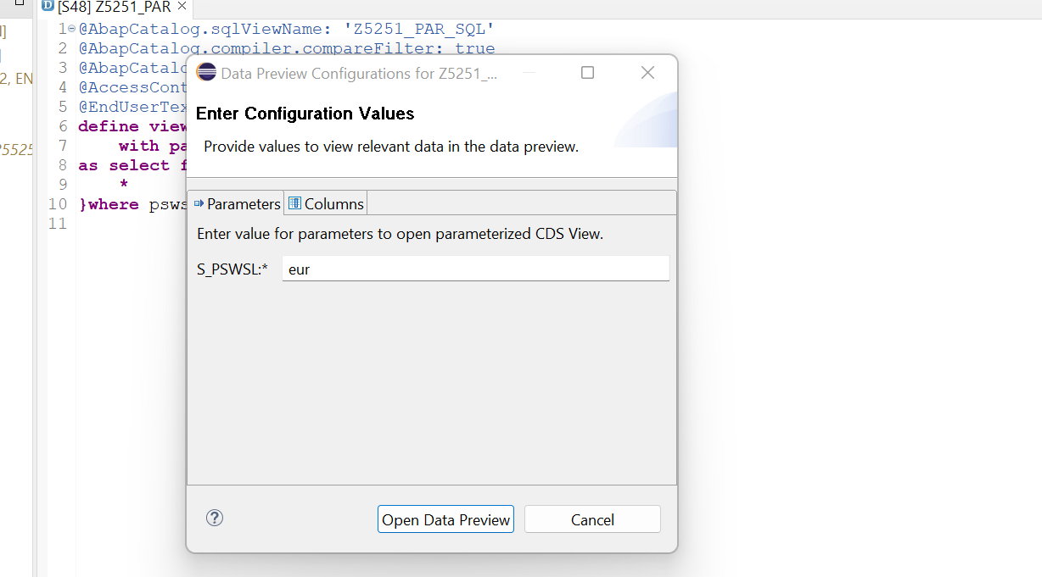

Output:

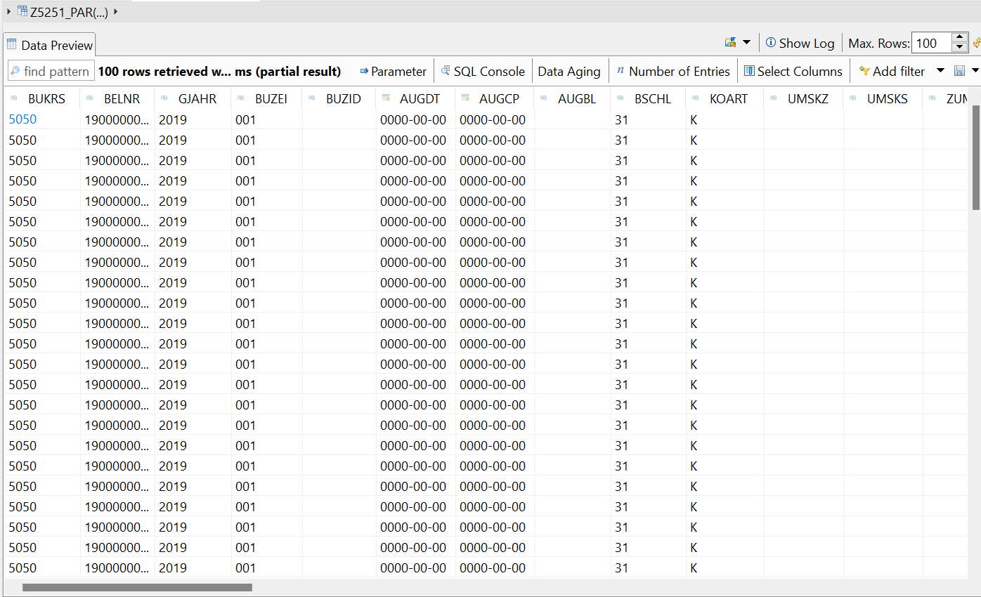

AMDP-Assignment 1 – Procedures - create a basic procedure to fetch data with scalar variable

CLASS CODE:

CLASS Z5251_CLASS1_D14 DEFINITION

PUBLIC

FINAL

CREATE PUBLIC .

PUBLIC SECTION.

INTERFACES :IF_AMDP_MARKER_HDB.

CLASS-METHODS: get_vbap_data

EXPORTING VALUE(lt_VBAP) TYPE Z5236TTSTU_VBAP.

PROTECTED SECTION.

PRIVATE SECTION.

ENDCLASS.

CLASS Z5251_CLASS1_D14 IMPLEMENTATION.

METHOD get_vbap_data BY DATABASE PROCEDURE FOR HDB LANGUAGE

SQLSCRIPT OPTIONS READ-ONLY

USING VBAP.

lt_vbap = select vbeln, matnr, ZMENG from vbap;

ENDMETHOD.

ENDCLASS.Report:

*&---------------------------------------------------------------------*

*& Report z5251_amdp1

*&---------------------------------------------------------------------*

* Description: *

REPORT Z5251_AMDP1.

Z5251_CLASS1_D14=>get_vbap_data( IMPORTING lt_vbap = DATA(ex_data) ).

TRY.

CALL METHOD cl_salv_table=>factory

IMPORTING

r_salv_table = DATA(lr_salv)

changing

t_table = ex_data.

CATCH cx_salv_msg.

ENDTRY.

lr_salv->display( ).

Output:

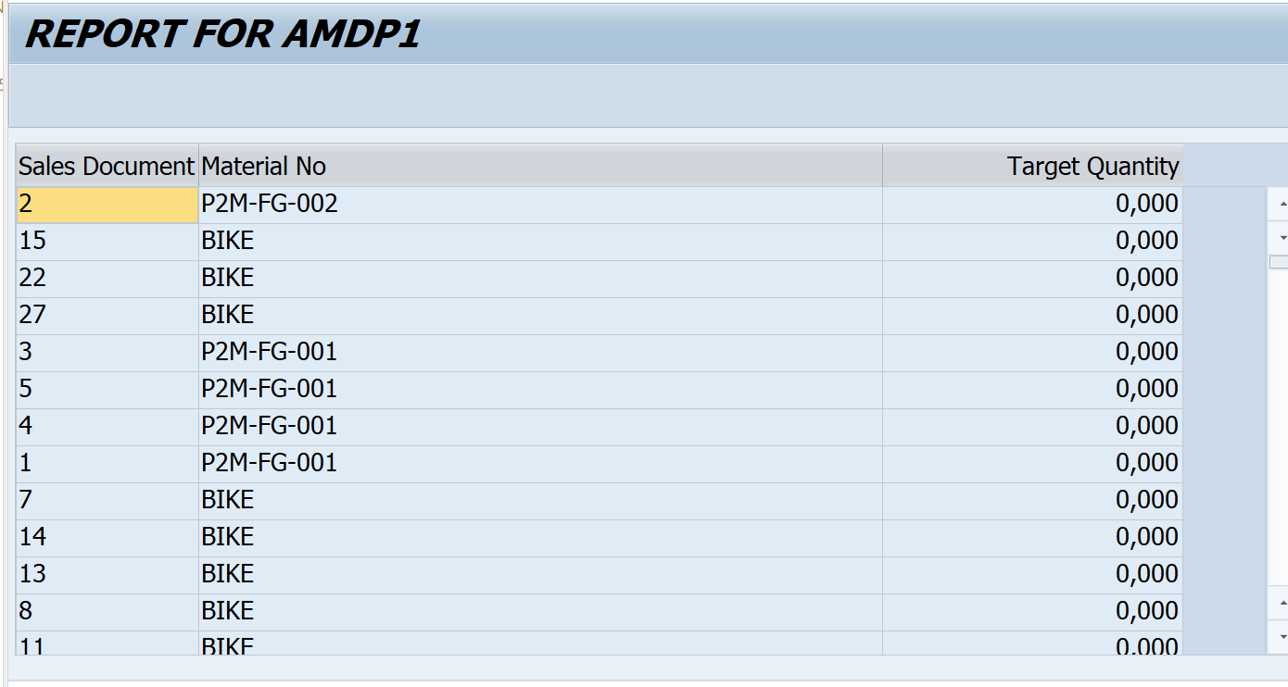

AMDP-Assignment 2 – Procedures - create a basic procedure with Table

Class code:

CLASS Z5251_CLASS2_D14 DEFINITION

PUBLIC

FINAL

CREATE PUBLIC .

PUBLIC SECTION.

INTERFACES : IF_AMDP_MARKER_HDB.

CLASS-METHODS:GET_DATA

IMPORTING VALUE(IM_MATNR) TYPE VBAP-MATNR

EXPORTING VALUE(ET_RES) TYPE Z5236TTSRU_IN.

PROTECTED SECTION.

PRIVATE SECTION.

ENDCLASS.

CLASS Z5251_CLASS2_D14 IMPLEMENTATION.

METHOD get_data BY DATABASE PROCEDURE FOR HDB LANGUAGE

SQLSCRIPT OPTIONS READ-ONLY

USING VBAP VBAK.

ET_RES = SELECT A.VBELN,

A.VKORG,

B.MATNR,

B.ZMENG

FROM VBAK AS A

INNER JOIN VBAP AS B

ON A.VBELN = B.VBELN;

ENDMETHOD.

ENDCLASS.

Report:

*&---------------------------------------------------------------------*

*& Report z5251_amdp2

*&---------------------------------------------------------------------*

REPORT Z5251_AMDP2.

PARAMETERS: S_MATNR TYPE VBAP-MATNR.

Z5251_CLASS2_D14=>get_data( EXPORTING IM_MATNR = S_MATNR

IMPORTING ET_RES = DATA(EX_RES) ).

TRY.

CALL METHOD cl_salv_table=>factory

IMPORTING

r_salv_table = DATA(lr_salv)

changing

t_table = ex_res.

CATCH cx_salv_msg.

ENDTRY.

lr_salv->display( ).

Selection screen:

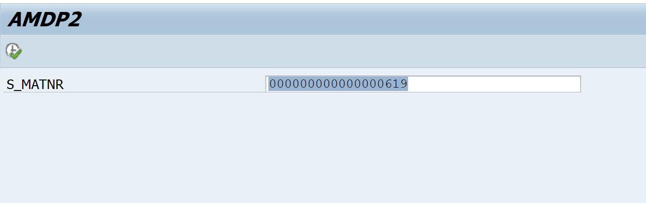

Output:

